Via: Email IPP_FRN@bls.gov

October 25, 2023

Bureau of Labor Statistics

ATTN: Assistant Commissioner Susan E. Fleck

International Price Program
U.S. Bureau of Labor Statistics, Room 2150
Postal Square Building
Massachusetts Avenue NE, Washington, DC 20212

Re: [FR Doc. 2023–19486] Request for Comment

Dear Assistant Commissioner Fleck:

Thank you for your invitation to comment on the technical approach to an upcoming major revision in the sources and methods used to estimate the Import and Export Price Indexes (MXPI).

For more than 100 years, the American Association of Exporters and Importers (AAEI) has served as a prominent national voice for the United States' international trade community. AAEI proudly represents a diverse range of industry sectors within the global trade landscape, comprising manufacturers, importers, exporters, wholesalers, retailers, and various service providers such as customs brokers, freight forwarders, trade advisors, insurers, security providers, transportation interests, and ports. Many of these entities are small businesses seeking opportunities to export to foreign markets. As the premier U.S. international trade organization, AAEI is recognized for its expertise in the day-to-day facilitation of trade, including the administration and compliance with import and export laws of the United States, making it an indispensable resource for those directly involved in and impacted by developments in international trade.

We support the revised approach that will replace directly collected survey data with administrative trade records from the Census Bureau for select, homogenous product areas. By incorporating millions of trade records monthly, not only will BLS be able to increase the number of publishable import and export price indexes, but it will significantly reduce the burden on respondents, including many importers and exporters. Currently, the data collected are based on a sample drawn from the frame of administrative trade data provided by importers and exporters to the U.S. government. The proposed new methods to calculate and aggregate unit value indexes can be reliably estimated using an estimation approach incorporating new methods, enhancements to current methods, and continuation of other processes currently in use. With the new data source, aggregation does not depend on importer and exporter data submissions.

If you have any questions or require any clarification of our responses, please contact my staff lead Mitchell Hart at Mitchell.hart@aaei-hq.org.

Sincerely,

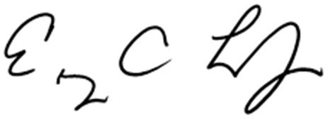
Eugene C. Laney
President & CEO

